Introduction to OOP

Over the years computer programming and computer languages have been continuously evolving based on the applications to be supported. We have different approaches like Procedural approach, Structured approach, and Modular approach. But the latest approach is the Object Oriented Approach (OOP).

OOP is a method where programming is adjusted and modeled on the basis of real life entities and processes. Object Oriented programming is a programming style which is associated with the concepts like class, object, Inheritance, Encapsulation, Abstraction, Polymorphism. OOP allows the programmer to create data variables or objects and processes. And these can be used and reused any number of times. It treats data as an important element and does not allow it to move freely in the program. It divides a program into building blocks called objects and then builds data and procedures/methods around these objects. The objects interact with each other through procedures/objects to perform a task. The method of one object can access the data of same object, which means that data can’t be accessed by external methods.

Most popular programming languages like Java, C++, C#, Ruby, Python, etc. follow an object oriented programming paradigm.

# PYTHON

Python is an interpreted, object-oriented, high-level programming language with dynamic semantics. Its high-level built in data structures, combined with dynamic typing and dynamic binding, make it very attractive for Rapid Application Development, as well as for use as a scripting or glue language to connect existing components together.

Python is relatively simple, so it's easy to learn since it requires a unique syntax that focuses on readability. Developers can read and translate Python code much easier than other languages. In turn, this reduces the cost of program maintenance and development because it allows teams to work collaboratively without significant language and experience barriers. Python supports modules and packages, which encourages program modularity and code reuse.

Python is a general-purpose programming language, which is another way to say that it can be used for nearly everything. Most importantly, it is an interpreted language, which means that the written code is not actually translated to a computer-readable format at runtime. Whereas, most programming languages do this conversion before the program is even run. This type of language is also referred to as a "scripting language" because it was initially meant to be used for trivial projects.

In fact, NASA actually uses Python when they are programming their equipment and space machinery.

*Applications of Python*

* Web and Internet Development
* Scientific and Numeric
* Education
* Desktop GUIs
* Software Development
* Business Applications

**Features of Python**

Python provides lots of features that are listed below :

1. Easy to Learn and Use ->

Python is easy to learn and use. It is developer-friendly and high level programming language.

1. Expressive Language ->

Python language is more expressive means that it is more understandable and readable.

1. Interpreted Language ->

Python is an interpreted language i.e. interpreter executes the code line by line at a time. This makes debugging easy and thus suitable for beginners.

1. Cross-platform Language ->

Python can run equally on different platforms such as Windows, Linux, Unix and Macintosh etc. So, we can say that Python is a portable language.

1. Free and Open Source ->

Python language is freely available at offical web address.The source-code is also available. Therefore it is open source.

1. Object-Oriented Language ->

Python supports object oriented language and concepts of classes and objects come into existence.

1. Extensible ->

It implies that other languages such as C/C++ can be used to compile the code and thus it can be used further in our python code.

1. Large Standard Library ->

Python has a large and broad library and prvides rich set of module and functions for rapid application development.

1. GUI Programming Support ->

Graphical user interfaces can be developed using Python.

1. Integrated ->

It can be easily integrated with languages like C, C++, JAVA etc.

Algorithm

1. Start
2. User is asked to input his/her choice from following options :-

* Search from name
* Search from number
* Adding Contact/s
* Adding Group/s
* Accessing Group by name

1. According to the option selected by user, steps to be followed are given below :-
2. Search from name
3. User is asked for the name or part of name
4. Name is searched in the Contact Book line by line and if name is found, a message is returned showing name and number of contact
5. If name is not found, message showing ‘Contact not found’ is shown
6. Search from Number
7. User is asked for the number or part of number
8. Number is searched in the Contact Book line by line and if number is found, a message is returned showing name and number of contact
9. If number is not found, message showing ‘Contact not found’ is shown
10. Adding Contact
11. User is asked for full name of the contact to be added
12. User is asked for phone number of the contact to be added
13. Contact is wrote to the file
14. Adding Group
15. User is asked for a unique name for the group
16. User is asked to start entering the full name of the contact to be added
17. User is asked for phone number of the contact to be added
18. Contact is wrote to the file
19. Process 2) to 4) are repeated until user enters a specific key to stop further contacts to be added
20. Accessing Group by name
21. User is asked for the name of the group
22. If no such group is found, a relevant message is shown
23. If group is found, the further choices are given to the user
24. Choice 1 : Search by name
25. User is asked for the name or part of name
26. Name is searched in the Contact Book line by line and if name is found, a message is returned showing name and number of contact
27. If name is not found, message showing ‘Contact not found’ is shown
28. Choice 2 : Search by number
29. User is asked for the number or part of number
30. Number is searched in the Contact Book line by line and if number is found, a message is returned showing name and number of contact
31. If number is not found, message showing ‘Contact not found’ is shown
32. Choice 3 : Add Contact
33. Choice 4 : Go back to the main menu
34. For any other choice, a relevant message is shown
35. A thanks message(or Emoji) is displayed
36. Program is Terminated

Source Code

#Start

print("\n\t\t\tWelcome to your contact Book\n")

while True:

while True:

print("\n Enter : ","1 for search from name","2 for search by number","3 for groups","4 for adding contact","5 for adding groups","0 for exiting",sep="\n")

ch=(input(" -> "))

if ch!="":

ch=int(ch)

break

if ch==0:

break

elif ch==1:

f=open("Contactbook.txt", "r")

n=input("\nEnter the name to be searched : ")

if f.mode == 'r':

l=f.readlines()

p=0

for a in l:

d=eval(a)

k=list(d.keys())

if n.lower() in k[0].lower():

p=1

print("\nContact Found","\n\nName:",k[0],"\nNumber:",d[k[0]])

if p==0:

print("\nContact not Found")

elif ch==2:

f=open("Contactbook.txt", "r")

n=input("\nEnter the number (complete or partially) to be searched : ")

if f.mode == 'r':

l=f.readlines()

p=0

for a in l:

d=eval(a)

k=list(d.keys())

l=list(d.values())

if n in l[0]:

p=1

print("\nContact Found","\n\nName:",k[0],"\nNumber:",d[k[0]])

if p==0:

print("\nContact not Found")

elif ch==4:

f= open("Contactbook.txt","a+")

a=input("\nEnter full name : ")

b=str(int(input("Enter phone number : ")))

d=dict()

d[a]=b

f.write(str(d)+"\n")

f.close()

elif ch==5:

s=(input("\nEnter group name : "))+".txt"

f= open(s,"w+")

f1=open("Groups.txt","a+")

f1.write(s+'\n')

f1.close()

print("Start entering members names and numbers\nTo exit press 0 in name")

while True:

a=input("\nEnter full name : ")

d=dict()

if a=="0":

break

d[a]=str(int(input("Enter phone number : ")))

f.write(str(d)+"\n")

f.close()

print("\n\tGroup created successfully !!")

elif ch==3:

name=input("\nEnter the name of the group : ")+".txt"

f1=open("Groups.txt","r")

if f1.mode == 'r':

p=0

l=f1.readlines()

for i in l:

if name+"\n"==i:

p=1

f1.close()

if p==0:

print("No Such group present!!")

if p==1:

while True:

f=open(name,"r")

if f.mode == 'r':

while True:

print("\nEnter : ","1 for search from name","2 for search by number","3 for adding contact","0 for going back to main menu",sep="\n")

ch=(input(" -> "))

if ch!="":

ch=int(ch)

break

if ch==0:

break

elif ch==1:

n=input("\nEnter the name to be searched : ")

l=f.readlines()

p=0

for a in l:

d=eval(a)

k=list(d.keys())

if n.lower() in k[0].lower():

p=1

print("\nContact Found","\n\nName:",k[0],"\nNumber:",d[k[0]])

if p==0:

print("\nContact not Found")

f.close()

elif ch==2:

n=input("\nEnter the number (complete or partially) to be searched : ")

l=f.readlines()

p=0

for a in l:

d=eval(a)

k=list(d.keys())

l=list(d.values())

if n in l[0]:

p=1

print("\nContact Found","\n\nName :",k[0],"\nNumber :", d[k[0]])

if p==0:

print("\nContact not Found")

f.close()

elif ch==3:

f.close()

f= open(name,"a+")

a=input("\nEnter full name : ")

b=str(int(input("Enter phone number : ")))

d=dict()

d[a]=b

f.write(str(d)+"\n")

f.close()

else:

print("\nWrong Choice")

else:

print("\nWrong Choice")

print("\t\t\t ^ ^ ")

print("\t\t\t ! ` ` !")

print("\t\t\t ' ")

print("\t\t\t <-> ")

#End

Output

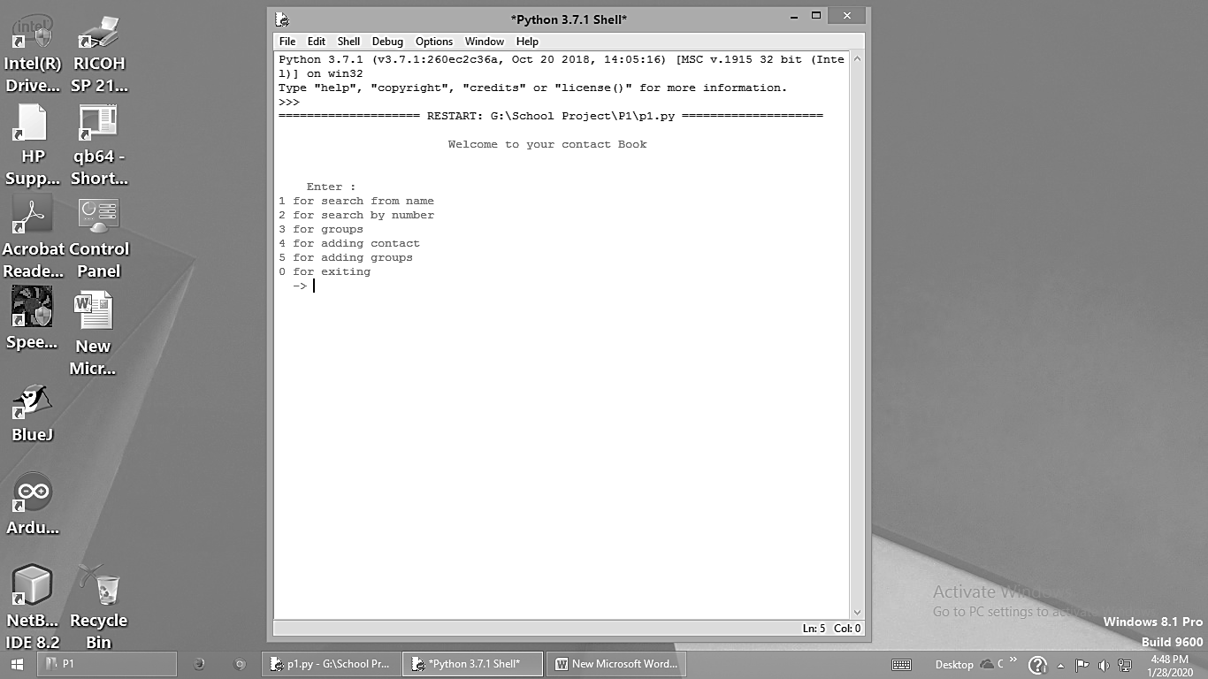

Option 1:

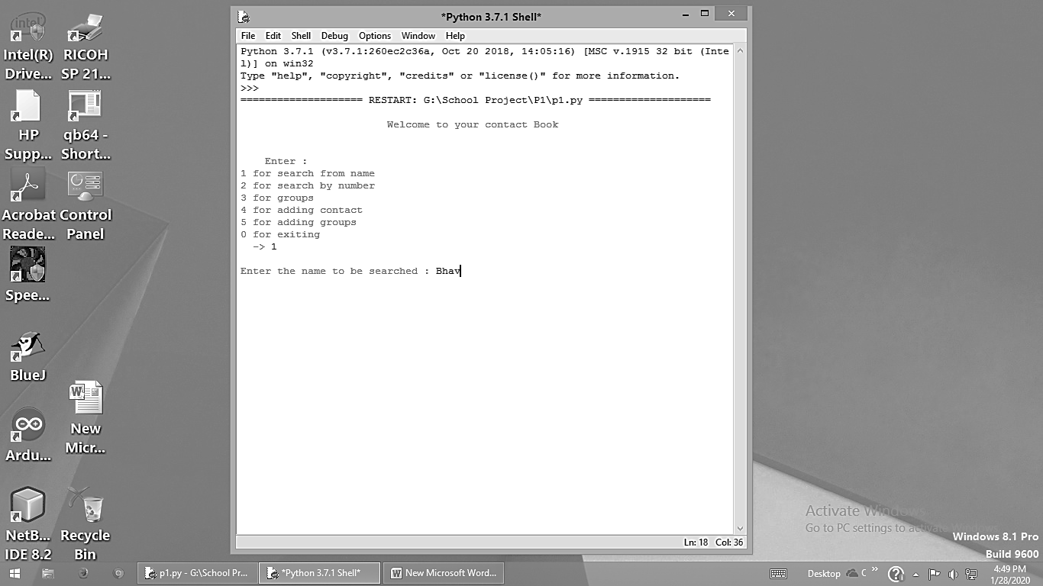

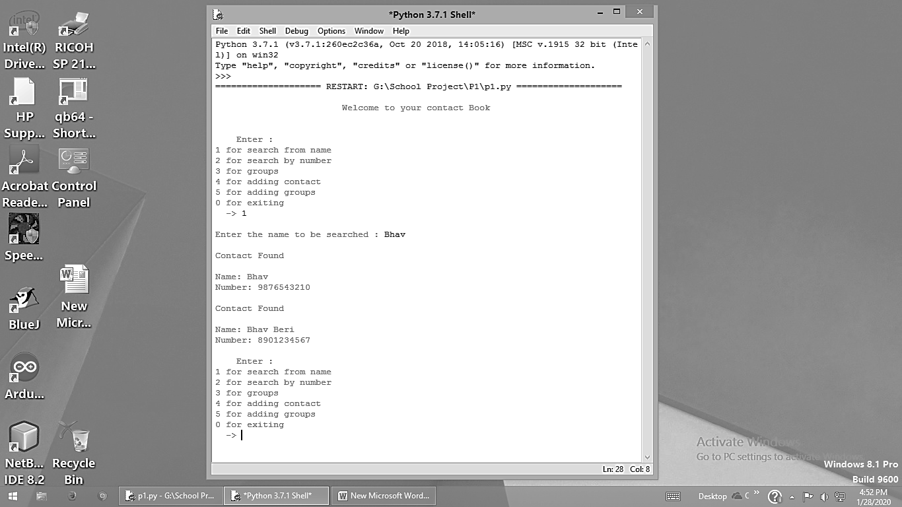

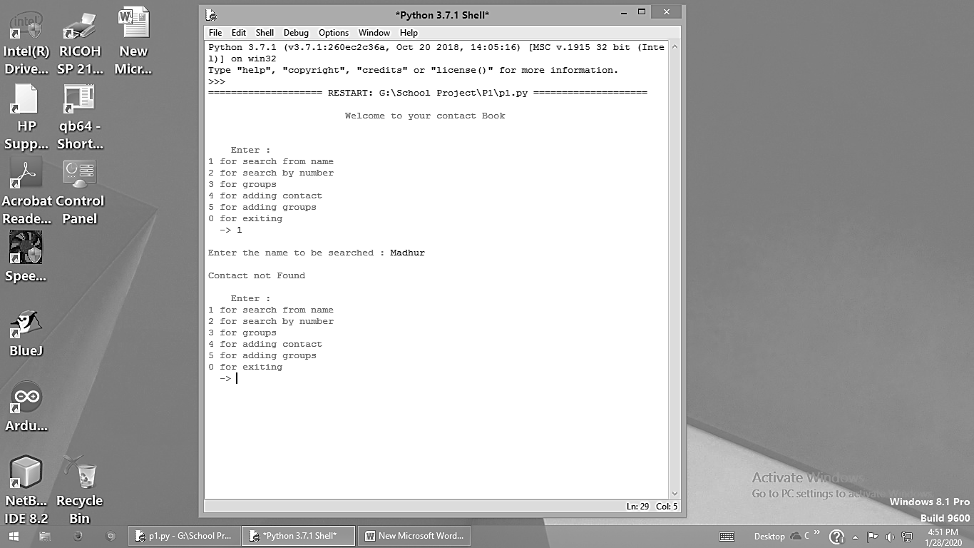

Option 2:

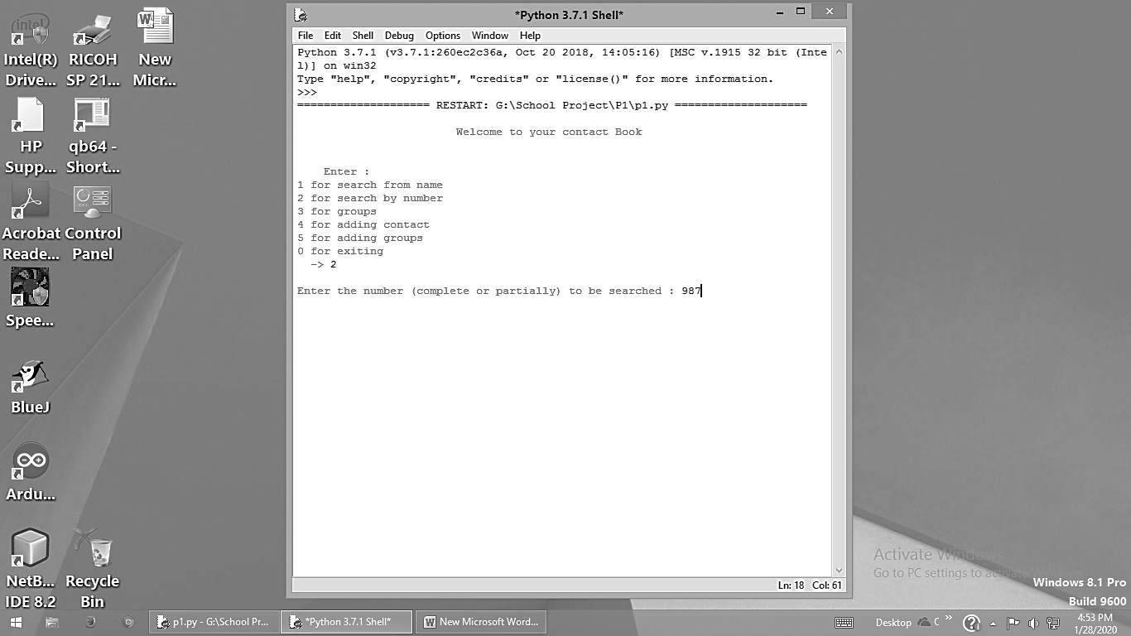

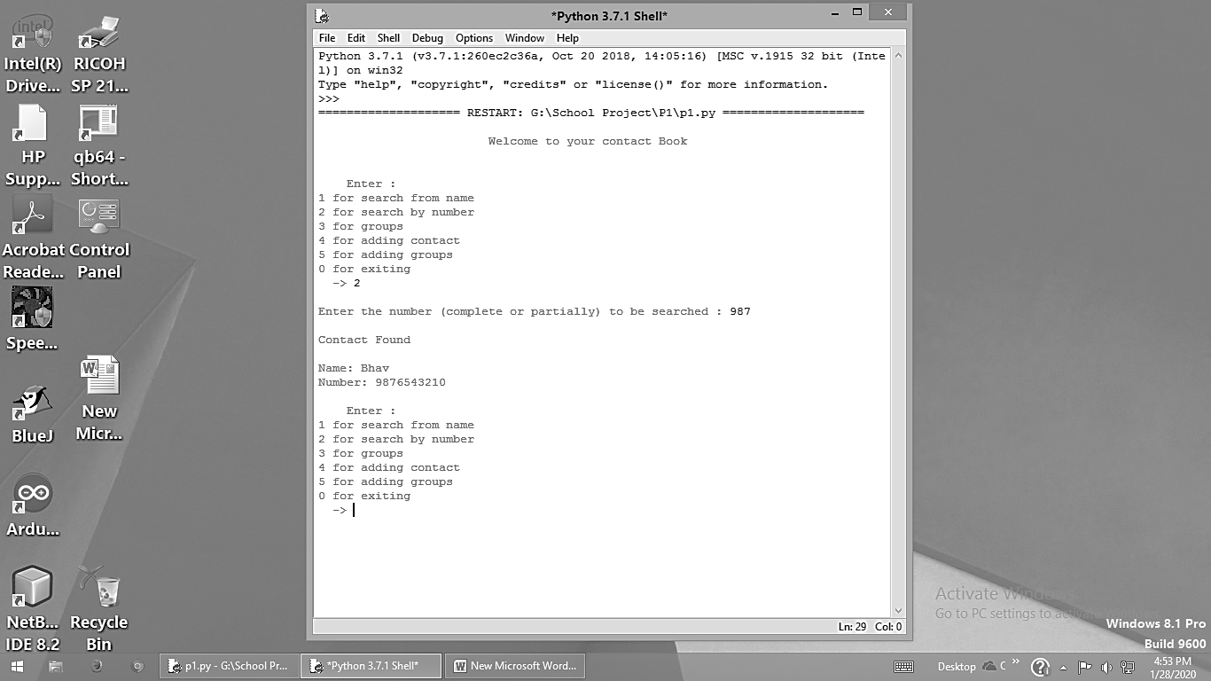

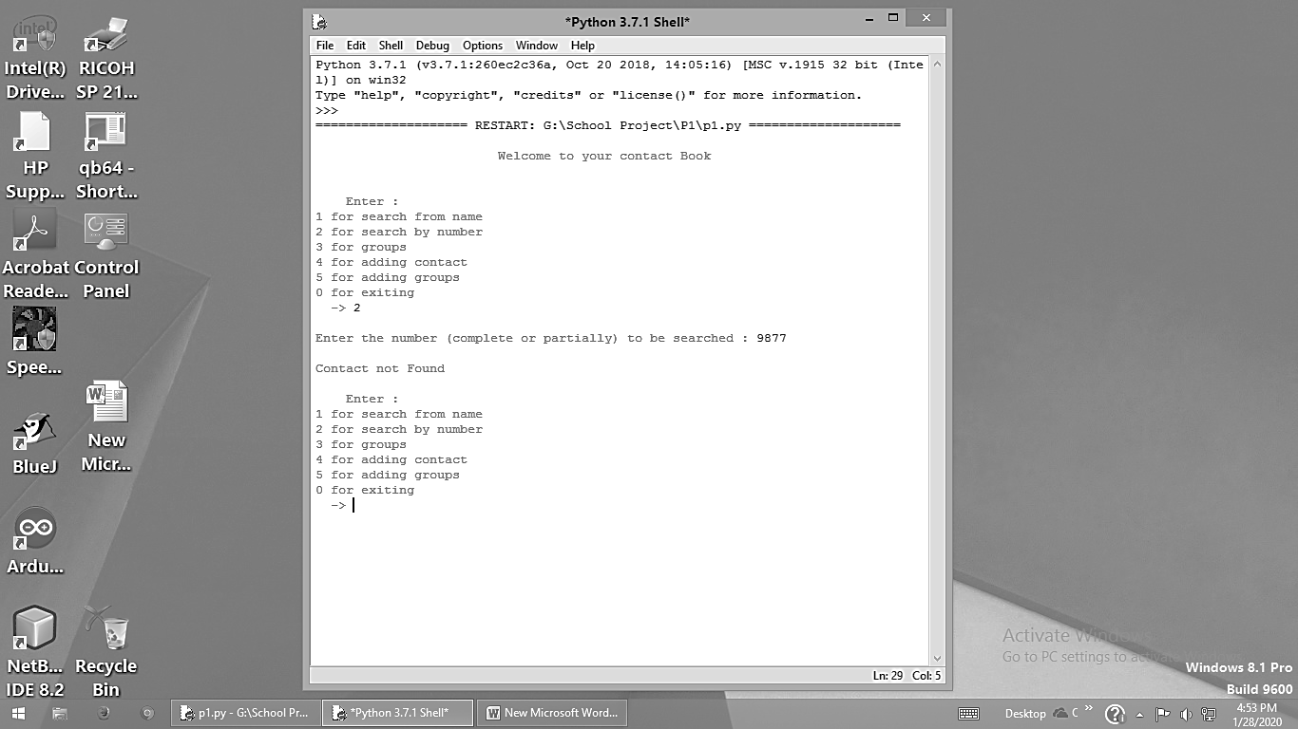

Option 3:

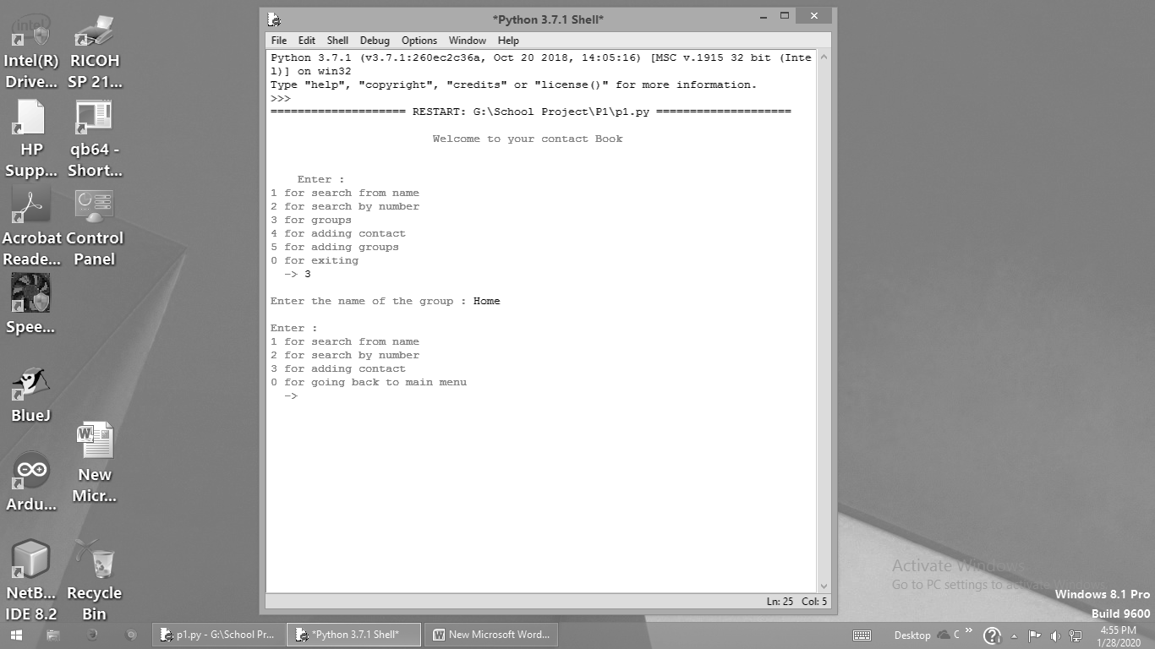

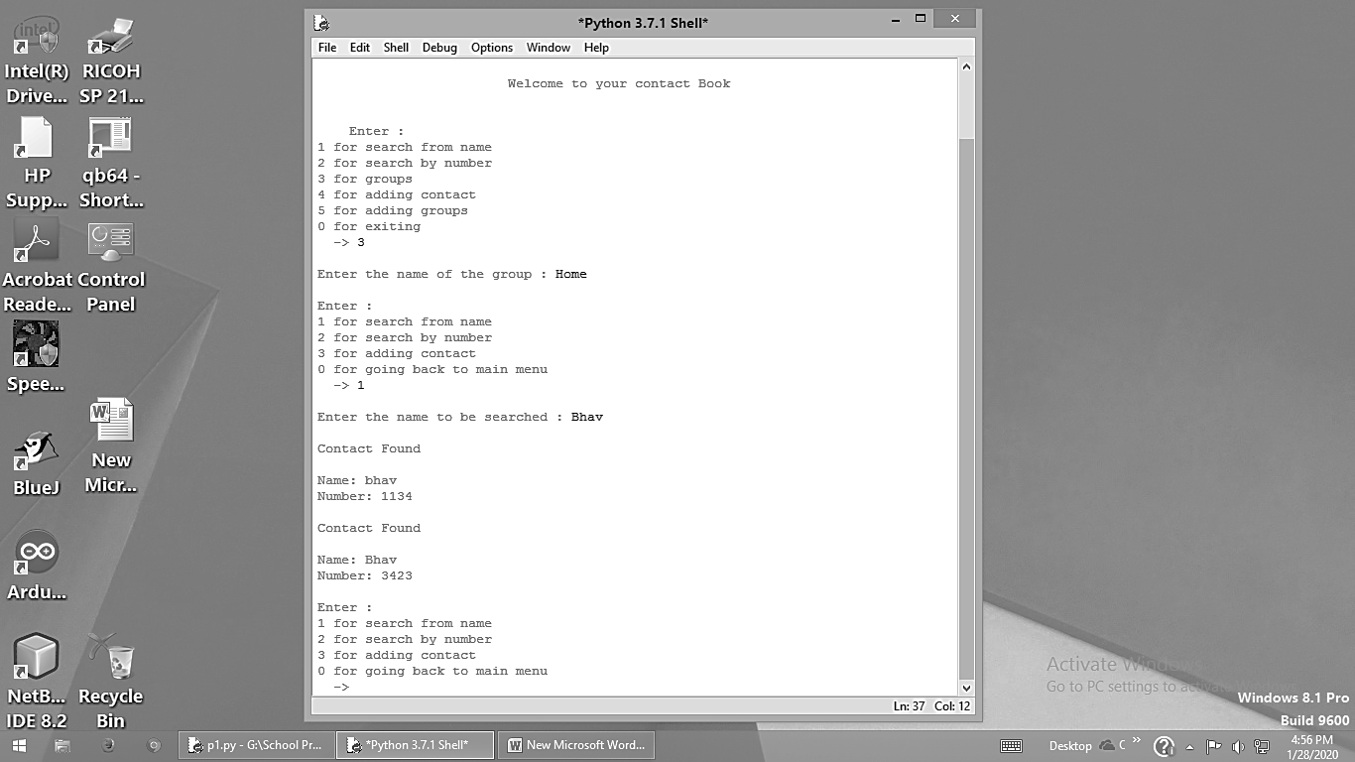

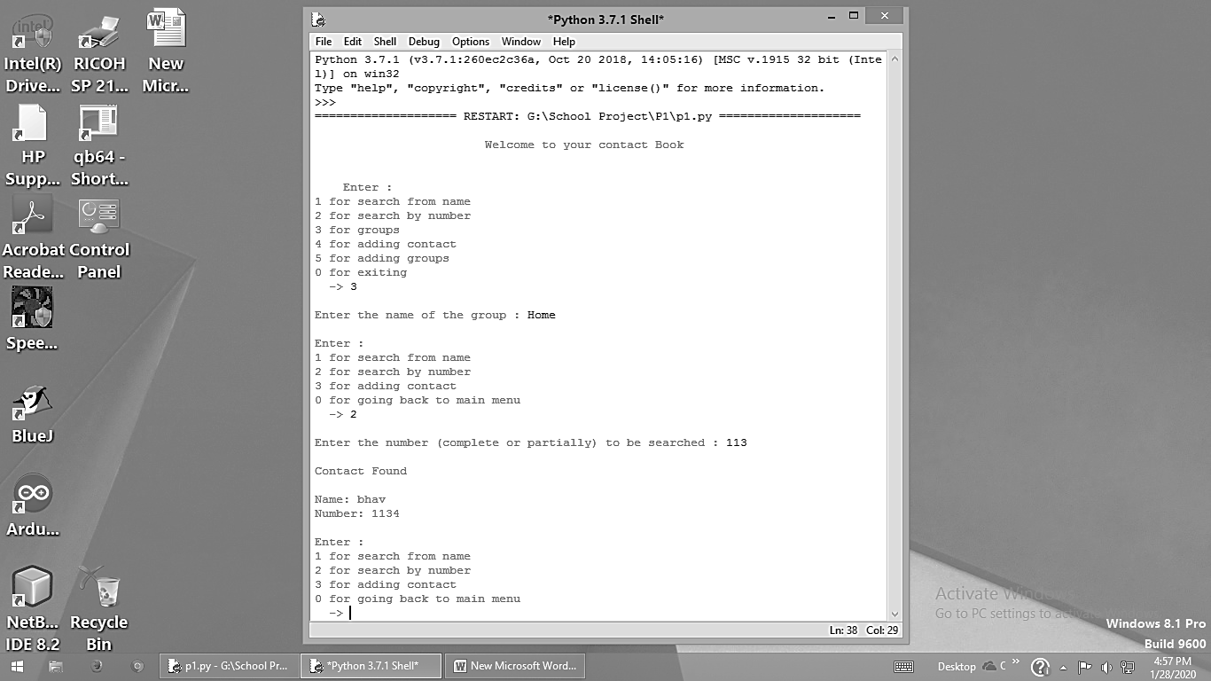

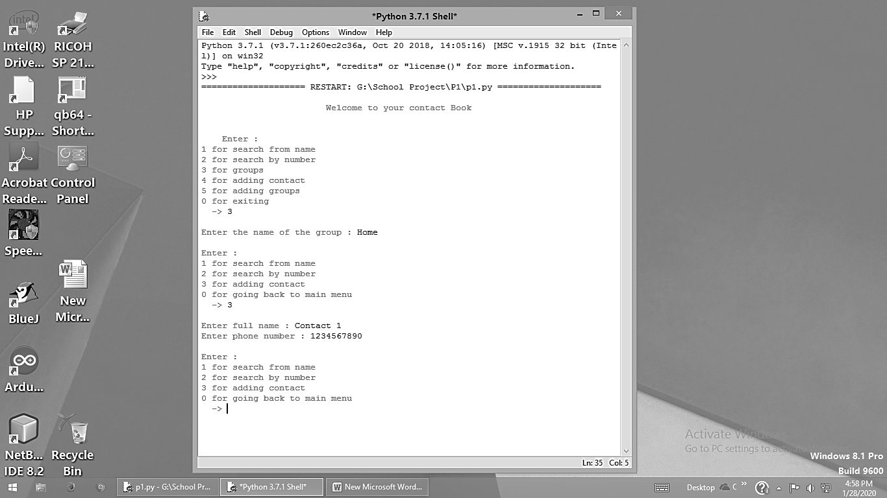

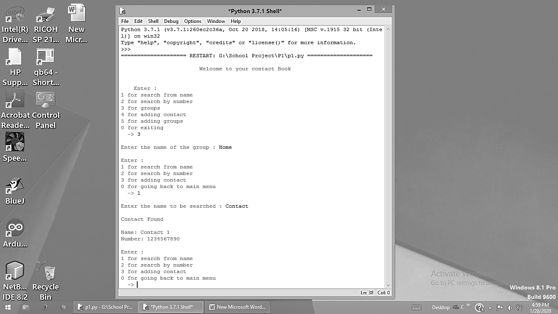

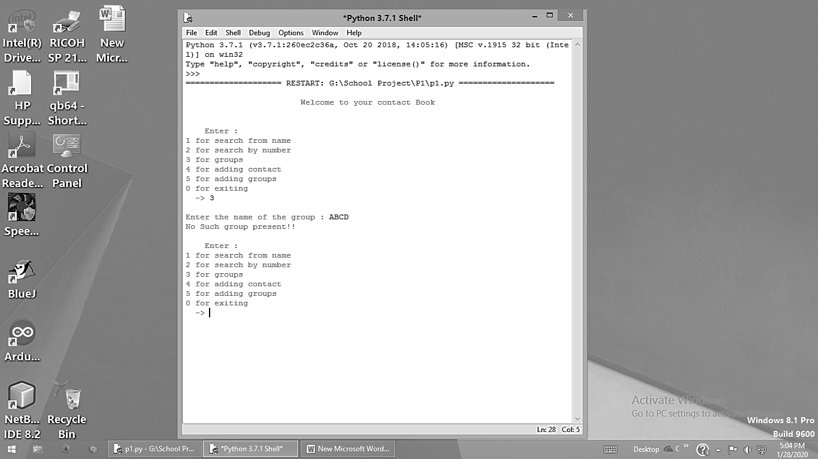

Option 4:

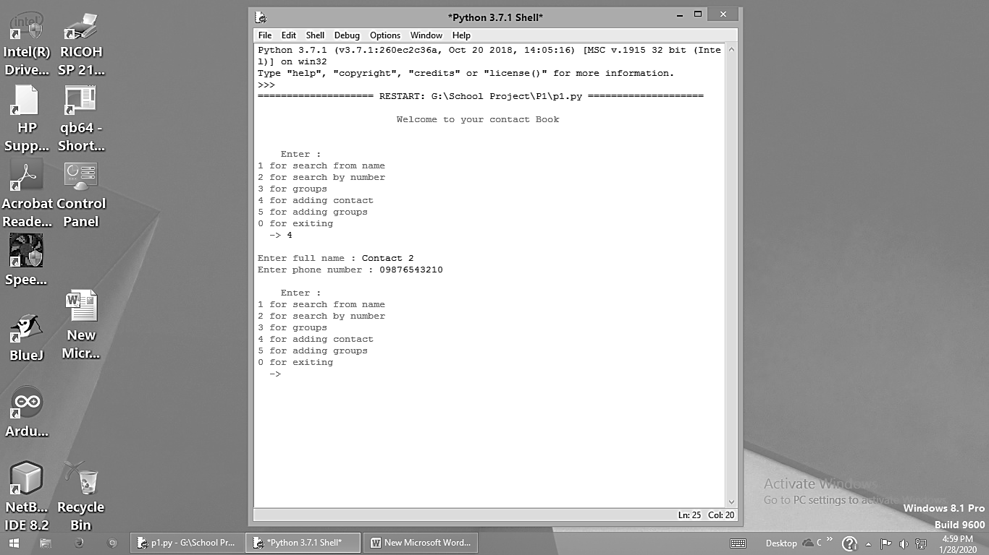

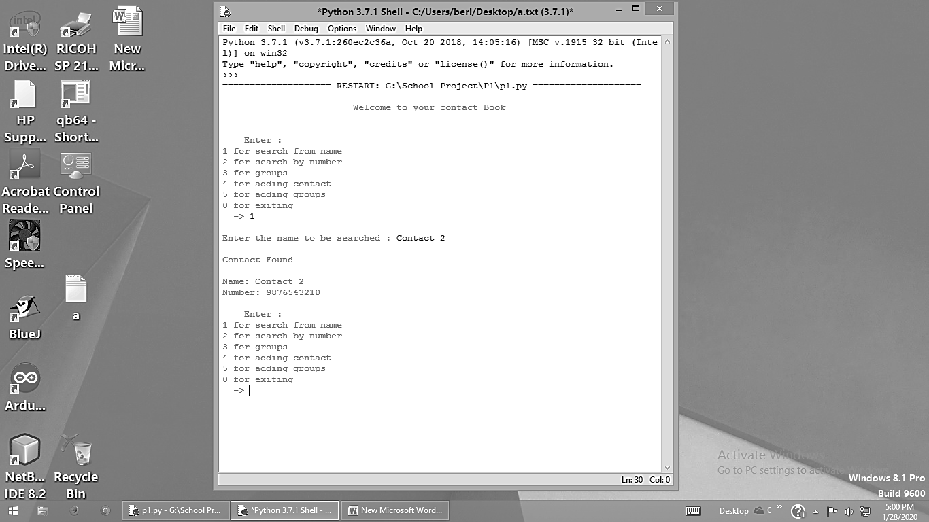

Option 5:

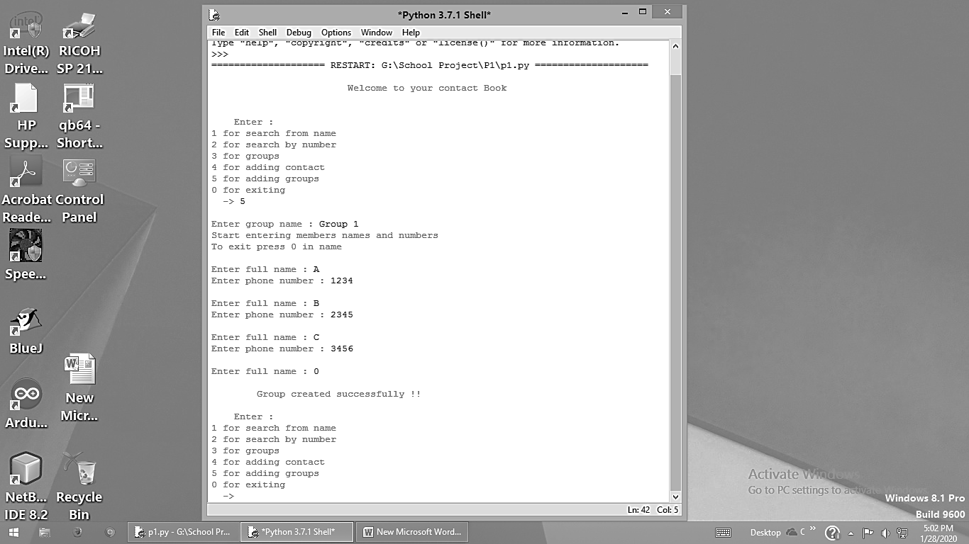

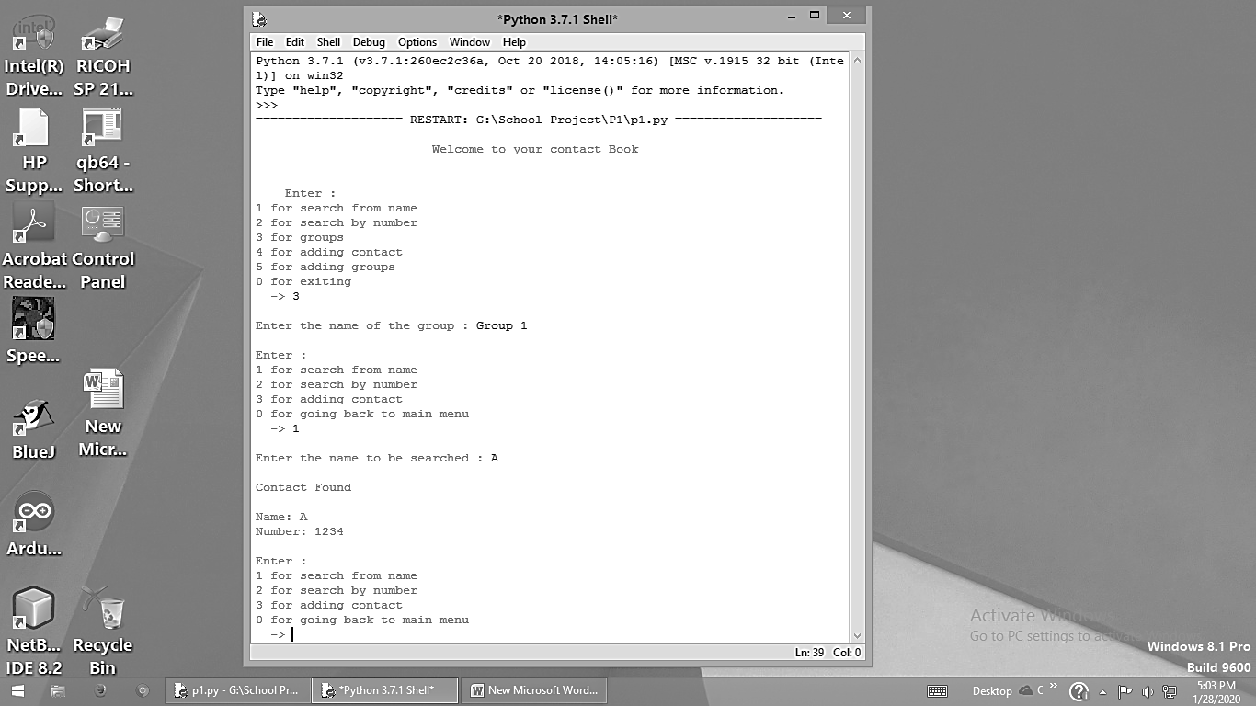

Others:

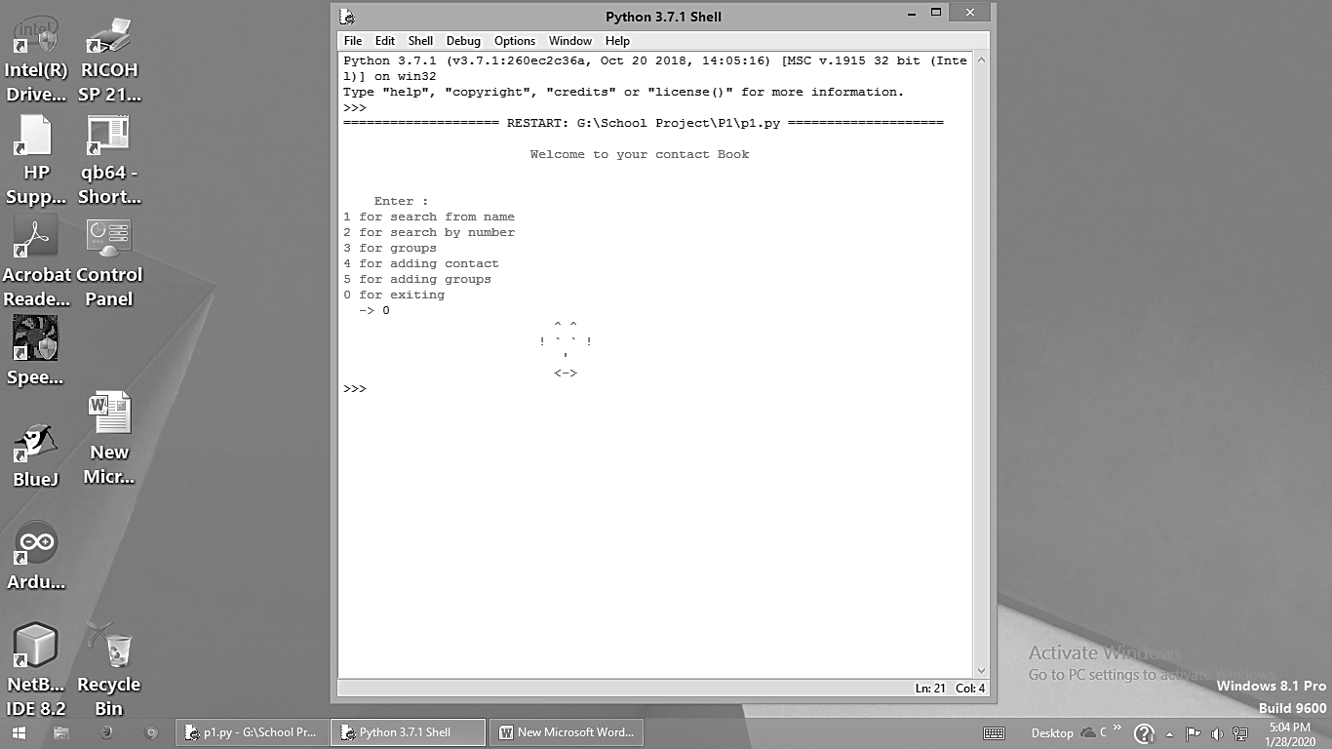

Data Saved in Files Permanently:

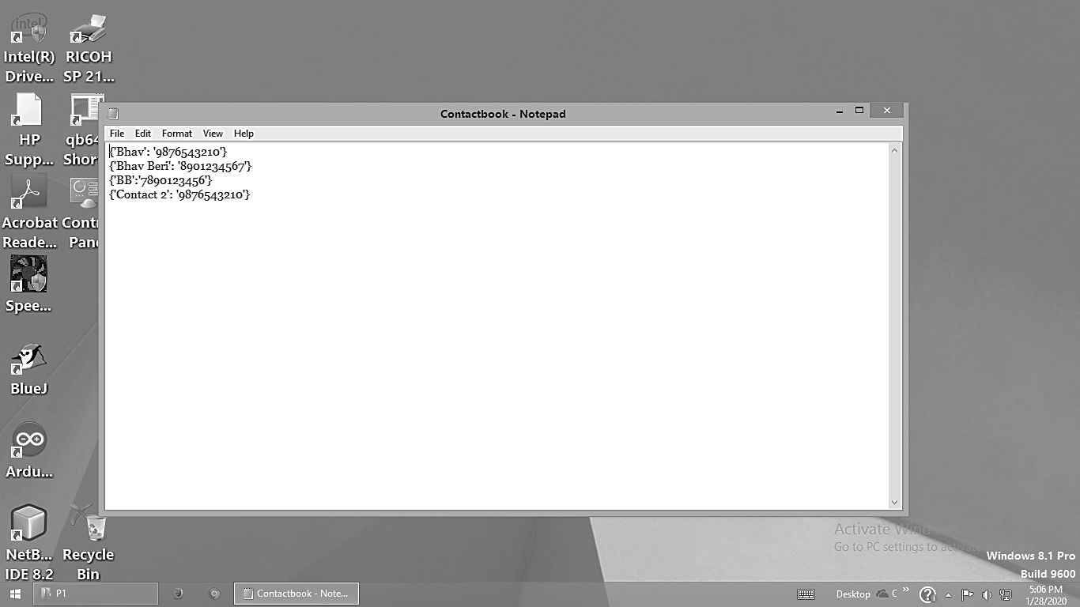

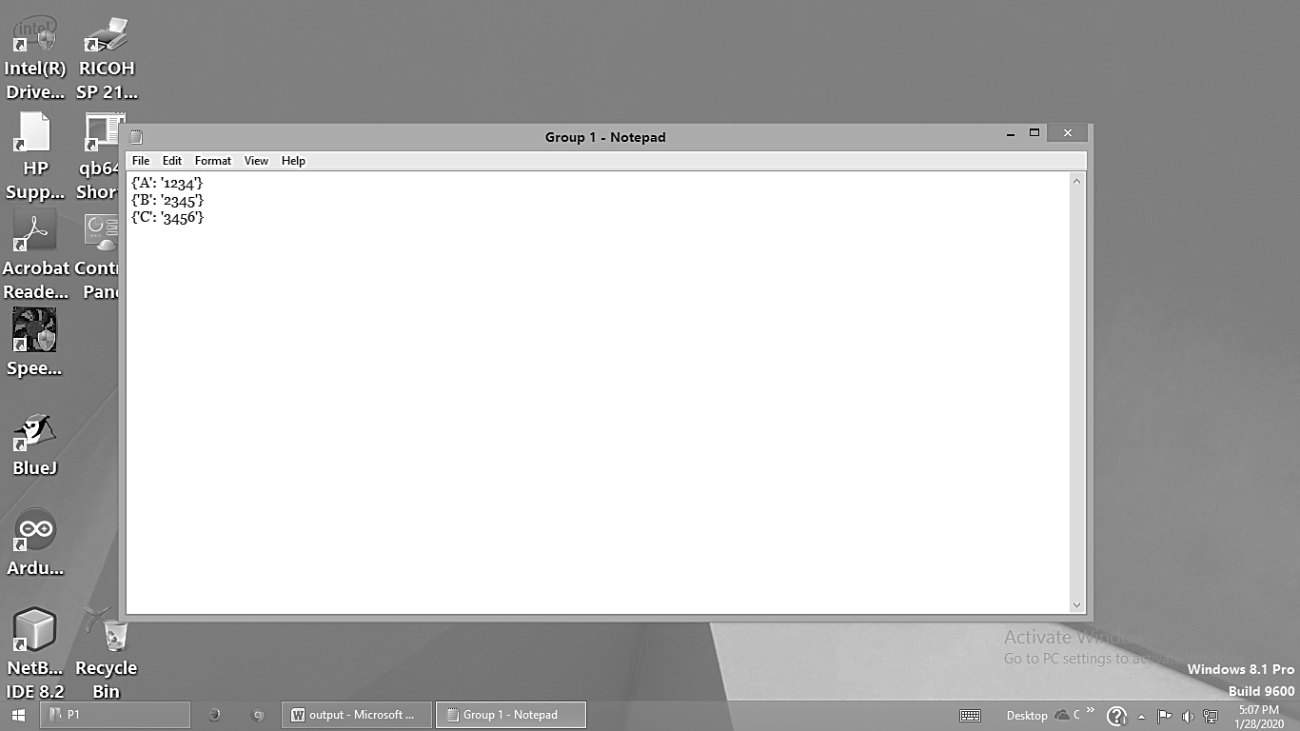

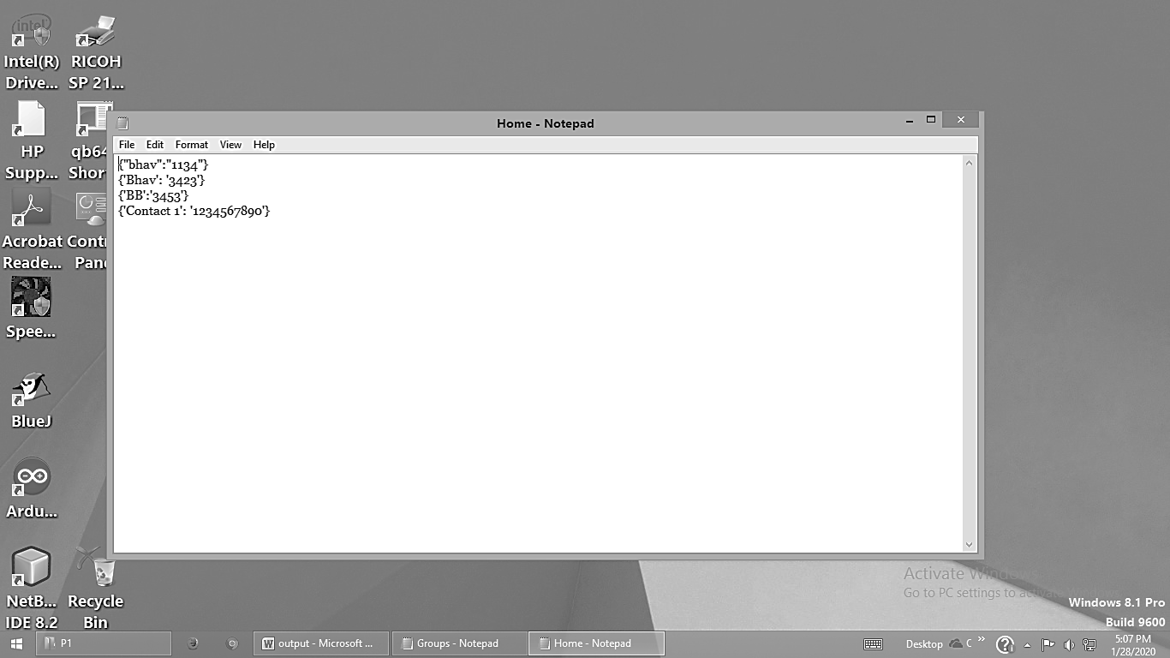

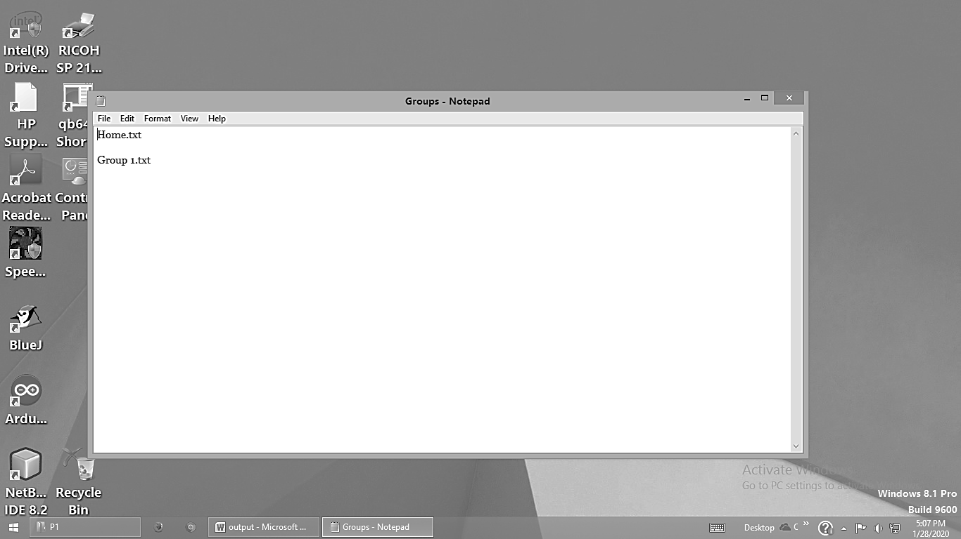

Statements used in the Source Code

* print() – Used to print a message onto the screen
* input() – Function which lets programmer ask a user for some text input
* if – Conditional statement used to implement selection constructs
* break – Skips rest of the loop and jumps over to statement following the loop
* str.lower() – Returns copy of string converted to lowercase
* list() – creates list from element/s
* dict.keys() – Access all the keys of dictionary
* dict.values() – Access all the values of dictionary

Reading and Writing Files

* open() – Its operation is to open file. This function take two arguments. The first one is file address and the other one is opening mode(a/r/w/a+/w+/r+)
* readlines() : This function returns a list where each element is single line of that file
* write() : This function writes a fixed sequence of characters to a file
* read() : This function reads the entire file and returns a string
* f.close() - This will close the instance of the file

Bibliography

* Software used Idle (Python 3.7 32-bit) with Python version 3.7.6 .
* Google.com
* javatpoint.com
* www.python.org
* www.pythonforbeginners.com
* www.dummies.com
* www.journaldev.com
* stackoverflow.com
* realpython.com
* geeksforgeeks.org
* learnpython.org
* guru99.com
* data-flair.training
* oreilly.com
* pythonforthelab.com